Experiment 5: Missionaries and Cannibals Problem
Aim
To write a Python program to solve the Missionaries and Cannibals problem.
Objective
- To transport all missionaries and cannibals safely across the river.
- To ensure that missionaries are never outnumbered by cannibals on either side.
Algorithm
- Start.
- Initialize the initial state.
- Generate all valid moves.
- Check whether the generated state is safe.
- If safe, move to the new state.
- Repeat until the goal state is reached.
- Display the solution.
- Stop.
Flowchart
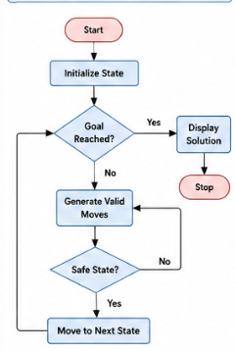
Pseudocode
BEGIN
Initialize the starting state
Generate valid moves
If state is safe
Move to next state
Repeat until goal is reached
Display solution
END
Result
Thus, all the missionaries and cannibals were transported safely across the river without violating the problem constraints.
Conclusion
Thus, the Missionaries and Cannibals problem was solved successfully using a state-space search approach.

Experiment 6: Vacuum Cleaner Problem
Aim
To write a Python program to implement the Vacuum Cleaner Problem.
Objective
- To clean all dirty rooms.
- To understand the working of a simple reflex agent.
Algorithm
- Start.
- Read the status of both rooms.
- Check the current room.
- If the room is dirty, clean it.
- Move to the next room.
- Repeat until both rooms are clean.
- Stop.

Flowchart
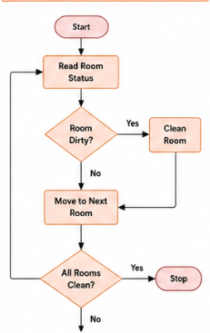
Pseudocode
BEGIN
Read room status
If room is dirty
Clean room
Move to next room
Repeat until all rooms are clean
END
Result
Thus, all the rooms were cleaned successfully.
Conclusion
Thus, the Vacuum Cleaner Problem was implemented successfully using a simple reflex agent.

Experiment 7: Breadth First Search (BFS)
Aim
To write a Python program to implement Breadth First Search.
Objective
- To traverse a graph level by level.
- To visit every node using BFS.
Algorithm
- Start.
- Create a queue.
- Insert the starting node.
- Visit the node.
- Add all unvisited adjacent nodes.
- Repeat until the queue becomes empty.
- Stop.
Flowchart
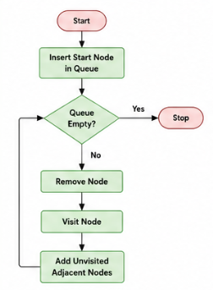
Pseudocode
BEGIN
Insert starting node into queue
While queue is not empty
Remove node
Visit node
Add unvisited neighbours
END
Result
Thus, all nodes were visited successfully using Breadth First Search.
Conclusion
Thus, Breadth First Search was implemented successfully to traverse the graph level by level.

Experiment 8: Depth First Search (DFS)
Aim
To write a Python program to implement Depth First Search.
Objective
- To traverse a graph using Depth First Search.
- To visit every node exactly once.
Algorithm
- Start.
- Select the starting node.
- Visit the node.
- Visit one adjacent unvisited node.
- Repeat until all nodes are visited.
- Stop.
Flowchart
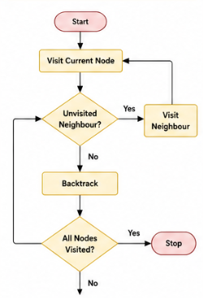
Pseudocode
BEGIN
Visit starting node
Visit adjacent unvisited node
Repeat until all nodes are visited
END
Result
Thus, all nodes were visited successfully using Depth First Search.
Conclusion
Thus, the graph was traversed successfully using the DFS algorithm.

Experiment 9: Travelling Salesman Problem (TSP)
Aim
To write a Python program to implement the Travelling Salesman Problem.
Objective
- To find the shortest route that visits every city exactly once.
- To return to the starting city with minimum cost.
Algorithm
- Start.
- Read the distance matrix.
- Generate all possible routes.
- Calculate the cost of each route.
- Select the route with minimum cost.
- Display the shortest path.
- Stop.

Flowchart

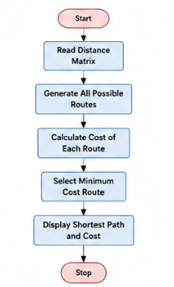
Pseudocode
BEGIN
Read distance matrix
Generate all possible routes
Find minimum cost route
Display shortest path
END
Result
Thus, the shortest route and minimum travelling cost were obtained successfully.
Conclusion
Thus, the Travelling Salesman Problem was implemented successfully by finding the minimum-cost tour.
Experiment 10: A Algorithm*
Aim
To write a Python program to implement the A* search algorithm.
Objective
- To find the shortest path between the start node and the goal node.
- To understand heuristic-based informed search.

Algorithm
- Start.
- Initialize the priority queue with the start node.
- Remove the node with the lowest cost.
- If it is the goal node, display the path.
- Otherwise, add all unvisited neighbouring nodes with their cost.
- Repeat until the goal node is reached.
- Stop.
Flowchart
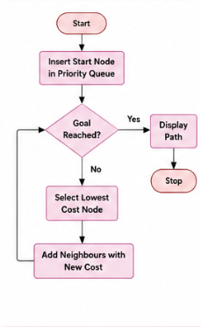
Pseudocode
BEGIN
Insert start node into priority queue
While queue is not empty
Remove node with lowest cost
If goal reached
Display path
Else
Add neighbouring nodes
END

Result
Thus, the shortest path from the start node to the goal node was found successfully using the A* algorithm.
Conclusion
Thus, the A* algorithm was implemented successfully using heuristic search to find the optimal path.

